SOURCE BOOKLET – Year 10 Geography
DO NOT WRITE ON THE SOURCE BOOKLET
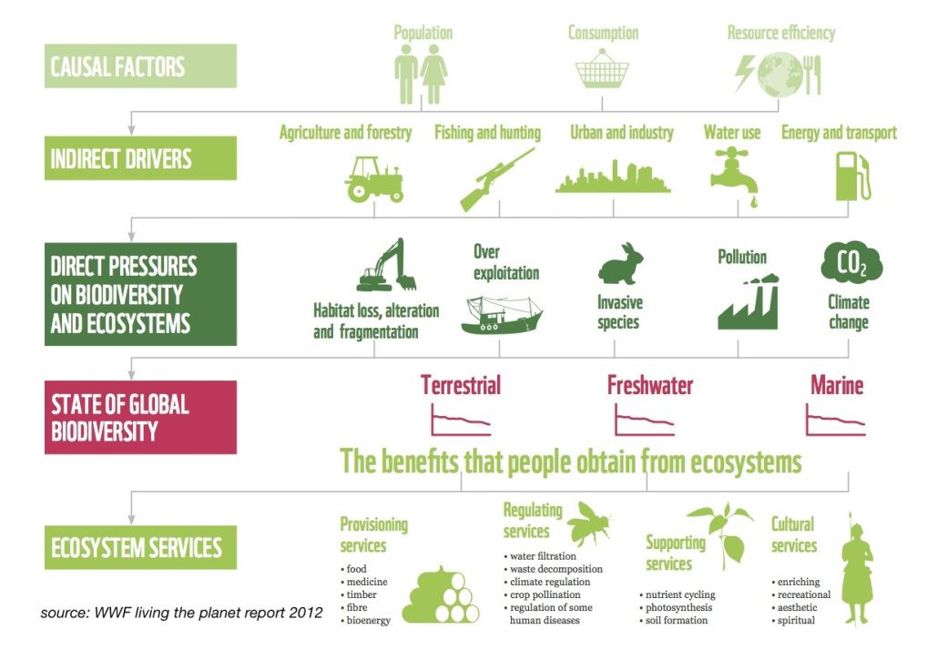
Source 1

SOURCE: https://cr2014studyabroad.wordpress.com/daily-topic-updates/ecosystem-services/ (Date accessed: 5/3/2018)

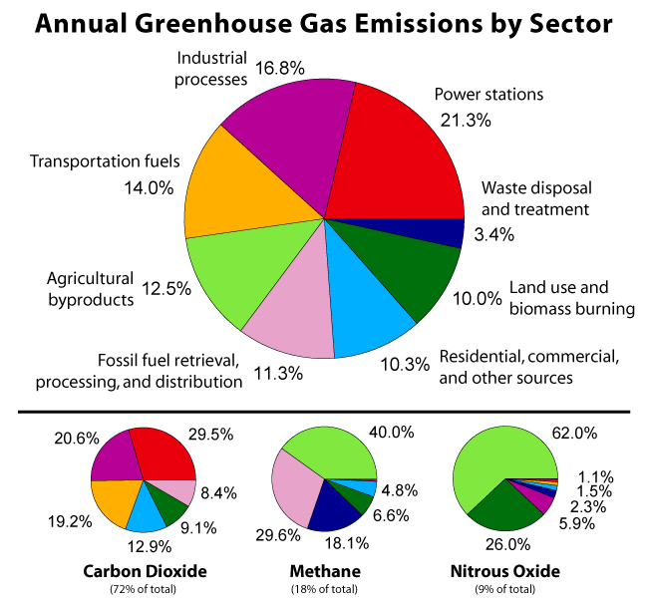
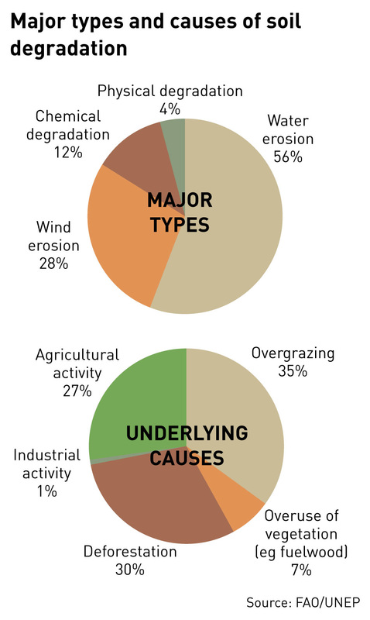
Source 3
Source 2

SOURCE: https://livelongthrive.wordpress.com/2014/02/06/resolving-nutritional-deficiency-naturally-part-5/ (Date accessed: 5/3/2018)

SOURCE: http://globalwarming-facts.info/causes-global-warming-human/ (Date accessed: 5/3/2018)
DO NOT WRITE ON THE SOURCE BOOKLET
Source 4
DO NOT WRITE ON THE SOURCE BOOKLET

Harris.G et al (2007). Humanities Alive Geography 10 Second Edition, John Wiley & Sons Australia, Milton
Source 5
DO NOT WRITE ON THE SOURCE BOOKLET
Kleeman.G et al (2008). Australian Explorations Stage 5 Geography, Heinemann Harcourt Education, Port Melbourne

